**Problem :** [**LeetCode 312 Burst Balloons**](https://leetcode.com/problems/burst-balloons/)

**Approach :**

**->** Need to Brute force,as difficult to find any pattern as array is not sorted.

-> So , for each window sizes of 1,2,3,...,n , find out what is the maximum coins you can get.

Just bcoz you are taking window sizes in ascending, while calculating for a window size of ‘x’,you already have optimal answers for window sizes from 1 to x-1.

-> E.g in figure below , 1 **4 6** 1 , **ans=max(when you take 6 last , when you take 4 last), whatever you take last, it has to be multiplied with 2 numbers on left and right immediately outside the window,and also ADD THE OPTIMAL ANSWER FOR THE LEFT AND RIGHT PARTS IN THE WINDOW IF ANY.**

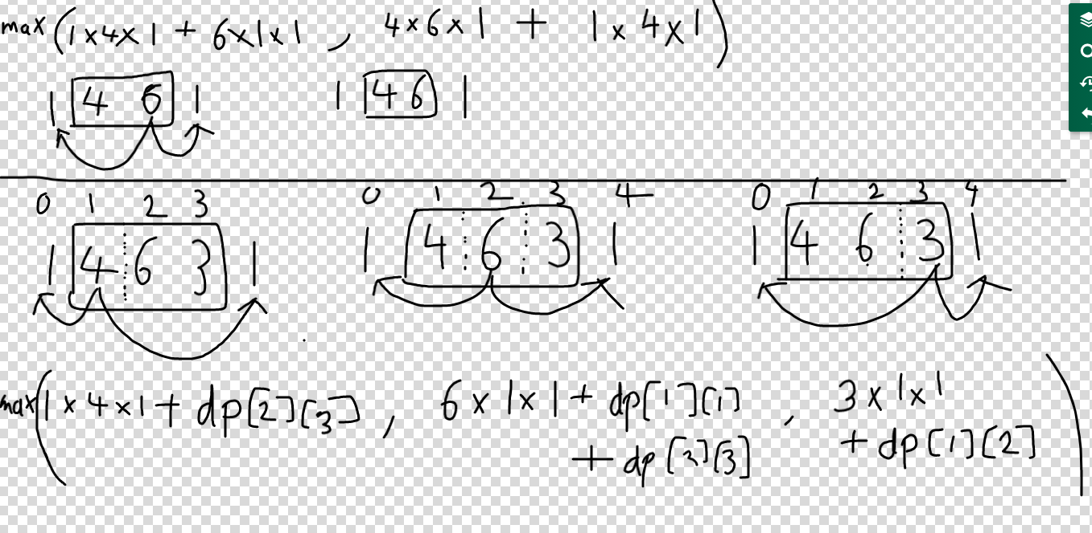

**->We have n^2 subarrays,and for every subarray we are traversing through length of that subarray, at most length is ‘n’, so Time Complexity = O(n^2 * n) = O(n^3)**

**Code :** [**https://ideone.com/Z4J8X4**](https://ideone.com/Z4J8X4)